
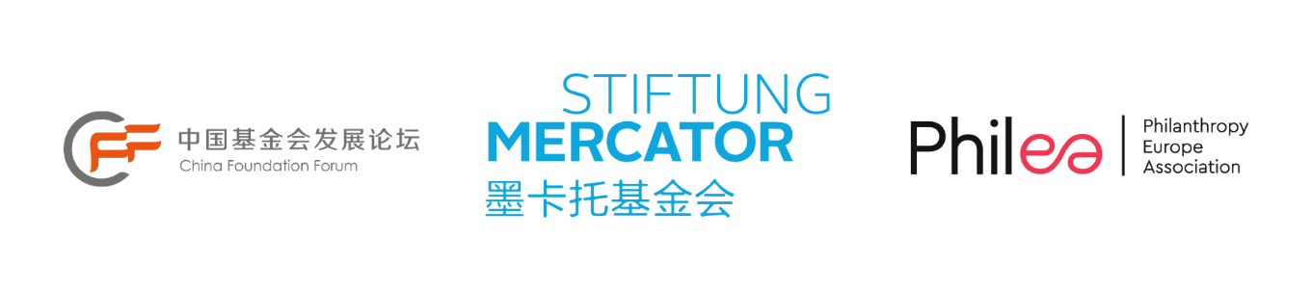
Philanthropic Leadership Platform: China-Europe
Application form

How to apply
To apply please submit this completed form to Bárbara Ortega via email to plp@philea.eu with the subject PLP: China-Europe and your name.

Costs
Participants are responsible for covering the costs of travel to/from the programme location. All other costs (meals, accommodation etc) associated with the programme will be covered by the organisers.

General information
Please fill in digitally.
Name
Surname
Date of birth
Email
Phone number
Organisation
City and Country
Organisation type | □ Private foundation (operational and/or grant-making)  □ Corporate foundation  □ Public charity or association  □ Philanthropy/social entrepreneurship infrastructure organisation  □ Other (please specify)  ……………………………………………………………………….

Professional information

Job title
Detailed description of your work (Max 100 words): Current responsibilities
Years in philanthropy field
Past professional experience (Past 5 years - job titles and organisations only in the last 5 years)
What is the highest level of education you have completed | □ BA (Bachelor's Degree)  □ MA (Master's Degree)  □ PhD (Doctoral Degree)  □ Other (Please specify)
Level of English | □ Native/Bilingual proficiency  □ Full professional proficiency  □ Professional working proficiency  □ Limited working proficiency  □ Elementary proficiency

Motivations and expectations
Why do you want to apply to this programme? (Max 200 words)
How does your organisation currently engage with global issues? (Max 200 words)
We encourage each participant to actively contribute to the exchange by either presenting a complex societal issue or an organisational problem that their organisation is currently facing —followed by a collective problem-solving exercise where participants can offer suggestions, similar to a case clinic approach—or sharing a specific skill or knowledge related to the theme of the exchange. Presentations should last between 10 and 15 minutes. Alternatively, participants may choose to organise an interactive activity.
This year's exchange focuses on equality and philanthropy, including the following topics:
- Evolving roles and approaches in philanthropy: Strategies and practices for promoting equality
- Philanthropic engagement for people and planet: Addressing Climate change, the new economy, and digitalisation with equity lenses
- Collaboration for equality: Strategic learning and collective Impact
- Inclusive leadership, trust, and strategic communications for advancing equality in philanthropy
Please provide a brief description of your topic and preferred presentation format. This topic can be further refined in collaboration with the organisers, and any preliminary ideas are welcome (Max 200 words)
Please identify operational areas you are individually interested in: (Max 3 for each column)
 | Areas I am most knowledgeable about |  | Areas I would like to build my skills in
Capacity building for grantee partners
Change management
Partnerships and network management
Data and knowledge management
Evaluation & strategic learning
Funding practices & grant-making
Investment practices
Leadership and organisational governance
Legal issues
Organisational Development
Partnership/collaboration
Policy and research
Project management
Raising funds from different entities
Strategic communications
Strategic planning
Other (Please specify): | ………………………………………………………………….
Please identify the SDG your organisation primarily works on:
 |  | Challenges the organisation is most knowledgeable about |  | Challenges the organisation would like to explore more
No Poverty
Zero Hunger
Good Health and Well-being
Quality Education
Gender Equality
Clean Water and Sanitation
Affordable and Clean Energy
Decent Work and Economic Growth
Industry, Innovation and Infrastructure
Reduced Inequalities
Sustainable Cities and Communities
Responsible Consumption and Production
Climate Action
Life Below Water
Life on Land
Peace and Justice Strong Institutions
Other (Please specify) |  | ………………………………………………….

Commitment Statement
Demand for Philea’s exchange programmes is high and spaces are limited, so we want to make sure that applicants are fully committed.
I hereby confirm my enthusiasm to fully participate in the programme, including all preparatory work as well as follow-up knowledge sharing. I will commit to learning, keeping in touch with my matched colleague and put to effect what I learn.
I confirm that my organisation is fully committed to my participation in the online and onsite exchange as well as all preparation and follow-up.
I understand that if I fail to attend the programme after confirming my participation and to submit a signed excuse, I may not be allowed to participate in future exchanges.
I give my permission to Philea to take photographs or video of me during the event and I authorise the use of the photographs or video by Philea for promotional or communications purposes.
Signature of the applicant:
Date:

About the organisers

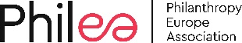 | Philea  We are the voice of European philanthropy. Our purpose is to harness its immense multidimensional potential. Philanthropy Europe Association (Philea) nurtures a diverse and inclusive ecosystem of foundations, philanthropic organisations and networks in over 30 countries that work for the common good. We unite over 10,000 public-benefit foundations that seek to improve life for people and communities in Europe and around the world.  We want to inspire, connect and represent the European philanthropy sector and enhance its role as a credible and trustworthy partner, today and tomorrow. We foster collaboration in order to increase synergies, scale up innovation and use our voice to impact policy that enables positive change  We believe that philanthropy in Europe plays a unique, risk-taking role in sparking innovation and acting as a catalyst for good. We want to connect citizens and communities with philanthropic organisations and contribute to building more resilient, sustainable and just societies. www.philea.eu
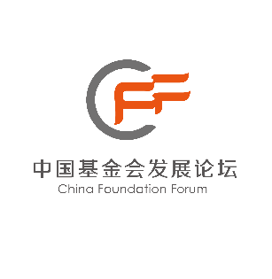 | China Foundation Forum  The China Foundation Forum (CFF) is a platform established voluntarily by foundations aiming at pursuing excellence and achieving progress in the foundation sector. In 2008 under the guidance of the State Administration of Civil Society of the Ministry of Civil Affairs, eight institutions initiated China Private Foundation Forum. In 2016 its name formally changed to China Foundation Forum. In 2017 the secretariat of China Foundation Forum registered at Beijing Civil Affairs Bureau as Beijing Jiye Evergreen Social Organization Service Center.  CFF adheres to principles of openness, sharing and striving for excellence. It aims to strengthen the communication and cooperation among Chinese foundations and build an ecosystem of China's foundation sector, so that the sector can become an important force to effectively solve social problems and promote the functioning of society. After more than ten years of development, CFF has become one of the most dynamic, influential and well-known brands in the public welfare sector.  http://www.cfforum.org.cn
 | Stiftung Mercator  Stiftung Mercator wants to make possible a comprehensive education and equal opportunities; to enhance the self-fulfilment of children, adolescents and young adults; to promote science and research relating to its objectives and areas of thematic focus in everyone’s interests; to support mutual understanding and exchange between people of different cultures; to commit itself to a unified Europe; to improve the social prerequisites for a peaceful coexistence of people of different backgrounds, convictions and social situations; and to preserve nature and the environment.  Stiftung Mercator intends to achieve this by making possible positive examples of social progress; stimulating the imagination of all who bear a particular responsibility in politics and society; and giving impetus, either on its own or in cooperation with partners, for the shaping of the future. Its activities should always be guided by quality, professionalism and transparency and subject to public debate.  https://www.stiftung-mercator.de/en/

