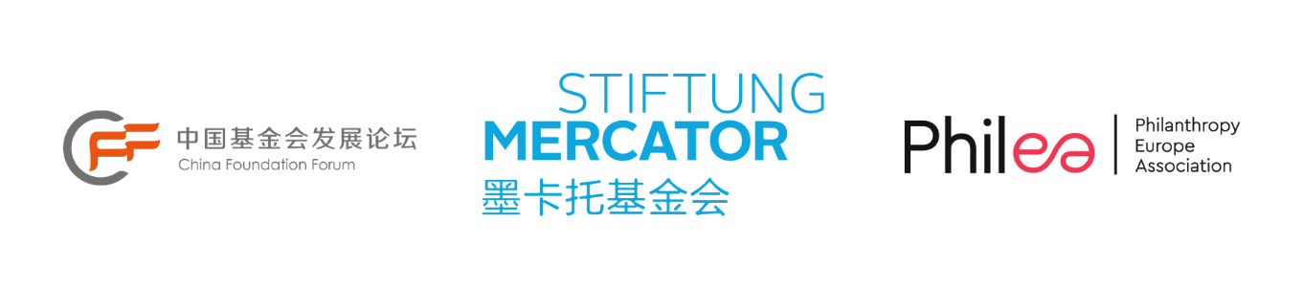
Philanthropic Leadership Platform: China-Europe
Application form

Context
At a time when there is growing recognition of philanthropy’s role and the need for intense collaboration in solving the world’s largest problems, fostering more and stronger ties between philanthropic traditions from across the globe are a must.
Having initiated the Philanthropic Leadership Platform: China-Europe in 2016, Stiftung Mercator and Philea are coming together again to design the latest edition of PLP: China-Europe with a new partner, the China Foundation Forum. After the pandemic having heavily affected engagement opportunities, we are delighted to create connections once again between both philanthropic traditions, with an emphasis on sharing the hands-on experience of working in philanthropy.
China and Europe are interdependent in various ways: they have strong trade and investment ties, they are partners in addressing global & regional challenges, with respect to the climate emergency. That is not to say there aren’t areas of tension where both regions need to engage and pursue the search for common ground.
Therefore, collaboration, respect, and mutually benefiting engagement remain of the utmost importance. In that respect, the sector of philanthropy can be a major force for good.
The new edition will gather a cohort of 20 philanthropy professionals; 10 from China; 10 from Europe, together to partake in a one-week gathering from the 18-23 September in Brussels, with Chinese peers engaging in an in-person alumni event in December 2023.

How to apply
To apply please submit this completed form to Prabhu Rajagopal via email to prabhu.rajagopal@philea.eu
European candidates for PLP China-Europe 2023 will be selected by a committee made up of Philea, the China Foundation Forum, a Chinese alumnus and a European alumnus, with the final selection announced on 15 May.

Costs
Participants are responsible for covering the costs of travel to/from the programme location. All other costs (meals, transportation) associated with the programme will be covered by the organisers.

Additional questions
For any questions contact Prabhu Rajagopal.

General Information
Please fill in digitally.
Name
Surname
Date of birth
Email
Phone number
Organisation
City and Country
Organisation type | □ Private foundation (operational and/or grantmaking)  □ Corporate foundation  □ Public charity or association  □ Philanthropy/social entrepreneurship infrastructure organisation  □ Other (please specify)  ……………………………………………………………………….

Professional Information

Job title
Detailed description of your work (Max 100 words): Current responsibilities
Detailed description of your work (Max 100 words): Key skills and achievements
Years in philanthropy field
Past professional experience (Roles & organisations in last 5 years)
Academic background
Level of English | □ Native/Bilingual proficiency  □ Full professional proficiency  □ Professional working proficiency  □ Limited working proficiency  □ Elementary proficiency

Motivations and expectations
Why do you want to apply to this programme? (Max 300 words)
How does your organisation currently engage with China? How long has this area of work been present in the organisation? If not currently present, what plans does your organisation have to engage with China? What role, if any, is yours in this context? (Max 300 words)
Describe how you plan to make use of the knowledge obtained during the programme in relation to your current responsibilities or those you expect to assume. (Max 250 words)
What is your preferred learning style (solitary, social/collaborative, investigative, reflective, visual, reading/writing or experiential approaches) and methods (plenary discussions, lectures and training, intergroup workshops, site visits etc.)? (Max 250 words)
Please outline a complex societal issue or an organisational problem that your organisation is facing. Would you be willing to bring this challenge to the exchange for a collective problem-solving exercise? (Max 250 words)
Willing to present it during the exchange: Yes  No 
Is there any skill or knowledge you would like to share with other participants? And how would you share it with others? (Max 300 words)
My area of expertise:

How I would share it with peers during the exchange (e.g.: I would be willing to facilitate a workshop or discussion, lead a session, purely participate as a peer, etc.):

Please identify operational areas you are individually interested in: (Max 3 for each column)
 | Areas I am most knowledgeable about |  | Areas I would like to build my skills in
Capacity building for grantees
Change management
Partnerships and network management
Data and knowledge management
Evaluation & strategic learning
Funding practices & grant-making
Investment practices
Leadership and organisational governance
Legal issues
Organisational Development
Partnership/collaboration
Policy and research
Project management
Raising funds from different entities
Strategic communications
Strategic planning
Other (Please specify): | ………………………………………………………………….
Please identify the SDG your organisation primarily works on:
 |  | Challenges the organisation is most knowledgeable about |  | Challenges the organisation would like to explore more
No Poverty
Zero Hunger
Good Health and Well-being
Quality Education
Gender Equality
Clean Water and Sanitation
Affordable and Clean Energy
Decent Work and Economic Growth
Industry, Innovation and Infrastructure |  | 
Reduced Inequalities
Sustainable Cities and Communities
Responsible Consumption and Production
Climate Action
Life Below Water
Life on Land
Peace and Justice Strong Institutions
Other (Please specify) |  | ………………………………………………….

Commitment Statement
Demand for Philea’s exchange programmes is high, and spaces are limited, so we want to make sure that applicants are fully committed.
I hereby confirm my enthusiasm to fully participate in the programme, including all preparatory work as well as follow-up knowledge sharing. I will commit to learning, keeping in touch with my matched colleague, and put to effect what I learn.
I confirm that my organisation is fully committed to my participation in the online and onsite exchange as well as all preparation and follow-up.
I understand that if I fail to attend the programme after confirming my participation and to submit a signed excuse, I may not be allowed to participate in future exchanges.
I give my permission to Philea to take photographs or video of me during the event and I authorise the use of the photographs or video by Philea for promotional or communications purposes.

Signature of the applicant:
Date:

About the organisers
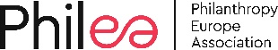 | Philea  We are the voice of European philanthropy. Our purpose is to harness its immense multidimensional potential. Philanthropy Europe Association (Philea) nurtures a diverse and inclusive ecosystem of foundations, philanthropic organisations and networks in over 30 countries that work for the common good. We unite over 10,000 public-benefit foundations that seek to improve life for people and communities in Europe and around the world.  We want to inspire, connect and represent the European philanthropy sector and enhance its role as a credible and trustworthy partner, today and tomorrow. We foster collaboration in order to increase synergies, scale up innovation and use our voice to impact policy that enables positive change  We believe that philanthropy in Europe plays a unique, risk-taking role in sparking innovation and acting as a catalyst for good.  We want to connect citizens and communities with philanthropic organisations and contribute to building more resilient, sustainable and just societies.  www.philea.eu
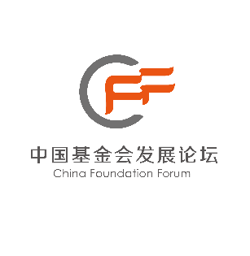 | China Foundation Forum  The China Foundation Forum (CFF) is a platform established voluntarily by foundations aiming at pursuing excellence and achieving progress in the foundation sector. In 2008 under the guidance of the State Administration of Civil Society of the Ministry of Civil Affairs, eight institutions initiated China Private Foundation Forum. In 2016 its name formally changed to China Foundation Forum. In 2017 the secretariat of China Foundation Forum registered at Beijing Civil Affairs Bureau as Beijing Jiye Evergreen Social Organization Service Center.  CFF adheres to principles of openness, sharing and striving for excellence. It aims to strengthen the communication and cooperation among Chinese foundations and build an ecosystem of China's foundation sector, so that the sector can become an important force to effectively solve social problems and promote the functioning of society. After more than ten years of development, CFF has become one of the most dynamic, influential and well-known brands in the public welfare sector.  http://www.cfforum.org.cn
Stiftung Mercator
Stiftung Mercator wants to make possible a comprehensive education and equal opportunities; to enhance the self-fulfilment of children, adolescents and young adults; to promote science and research relating to its objectives and areas of thematic focus in everyone’s interests; to support mutual understanding and exchange between people of different cultures; to commit itself to a unified Europe; to improve the social prerequisites for a peaceful coexistence of people of different backgrounds, convictions and social situations; and to preserve nature and the environment.
Stiftung Mercator intends to achieve this by making possible positive examples of social progress; stimulating the imagination of all who bear a particular responsibility in politics and society; and giving impetus, either on its own or in cooperation with partners, for the shaping of the future. Its activities should always be guided by quality, professionalism and transparency and subject to public debate.
https://www.stiftung-mercator.de/en/

